GERBODE DEFECT IN AN ADULT PATIENT: A VERY RARE ENTITY
R. Malik, S. Hussain, H. Keshmiri, S. Danciu
Advocate Illinois Masonic Medical Center, Chicago, IL, USA

Background: A communication between the left ventricle (LV) and right atrium (RA) is a rare type of ventricular septal defect (VSD). They are more often congenital than acquired. The incidence of LV-RA communication is 0.08% of all catheterized congenital defects. It was first described in the 19th century and was recognized as the Gerbode defect in 1958 when Gerbode et al. published a series of five patients who underwent successful surgical repair.
Case: 57-year-old male with a past medical history of HTN presented with symptoms of worsening shortness of breath and chest pain. On auscultation was found to have a loud holosystolic murmur in the left lower sternal border. Transthoracic echocardiogram revealed an anomalous left to right shunt. To better characterize the shunt a transesophageal echocardiogram was performed. It revealed a turbulent jet originating from the LV directed to the RA travelling above the tricuspid valve (fig 1). An accurate quantification of anomalous shunt could not be performed due to contamination from tricuspid regurgitation jet. Cardiac catheterization was performed to visualize (fig 2) and precisely quantify the shunt (Qp/Qs 1.9). Patient was referred for surgical closure of the defect.
Conclusion: Gerbode ventriculo-atrial defect is a rare defect that permits shunting from the left ventricle to the right atrium. Anatomically, the defect is characterized as above the tricuspid valve (type I), below the tricuspid valve (type II), or a combination of both (type III). Literature review suggests most of these cases require surgery. Repair of such defects is challenging and requires great expertise.

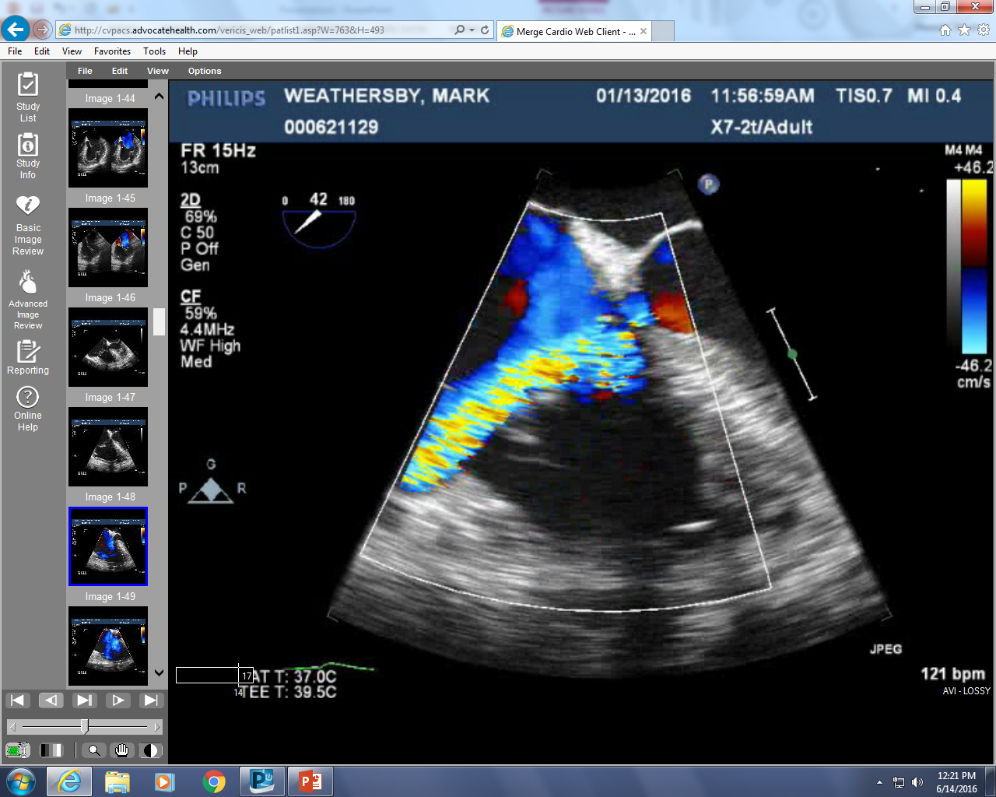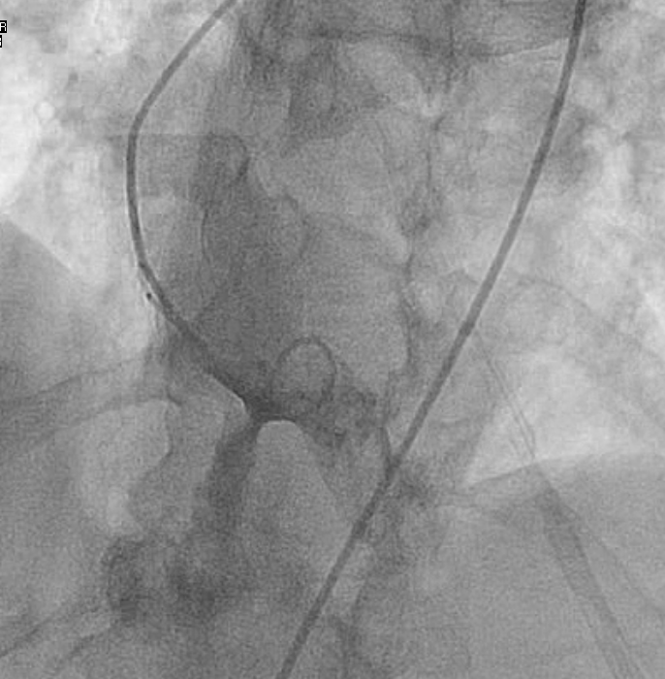
Fig. 1 Fig. 2

